Build a Virtual Private Cloud (VPC)
By Haroon Zaman | November 2025

Introduction
I am doing this project to learn the fundamentals of AWS networking and how to design a secure cloud environment. By building a VPC, I aim to understand how cloud resources communicate, how networking works in AWS, and how to create the foundation for more advanced cloud architectures.
In this project, I performed the following tasks:
- Created a VPC – I set up my own private network in AWS, defining an IPv4 CIDR block to control IP ranges and ensure proper communication between resources.
- Created Subnets – I divided my VPC into subnets, which act like neighborhoods to organize resources and manage traffic flow.
- Created an Internet Gateway – I attached an internet gateway to my VPC, allowing my resources to connect to and be accessed from the internet securely.

Virtual Private Clouds (VPCs)
A VPC (Virtual Private Cloud) is a private network inside AWS where we control IP ranges, subnets, routing, and security. It allows us to securely host resources like EC2 instances and databases while managing how they communicate with each other.
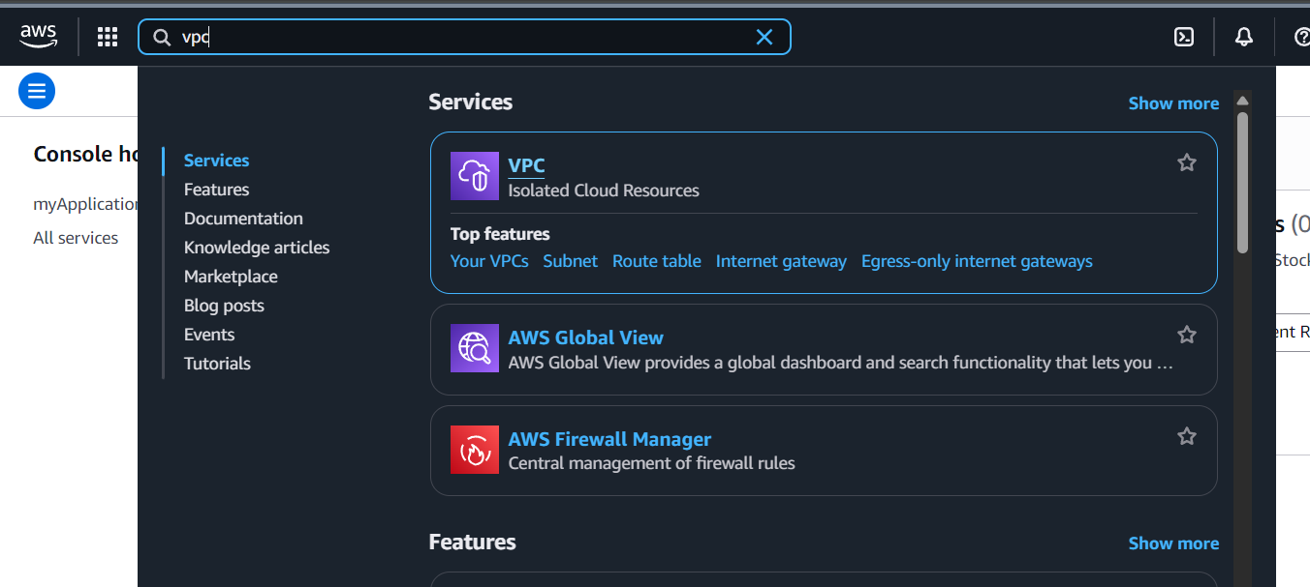
First, I logged in to my AWS account. I typed VPC in the top search bar and clicked on it to open the VPC dashboard, where I could start creating my own private network.
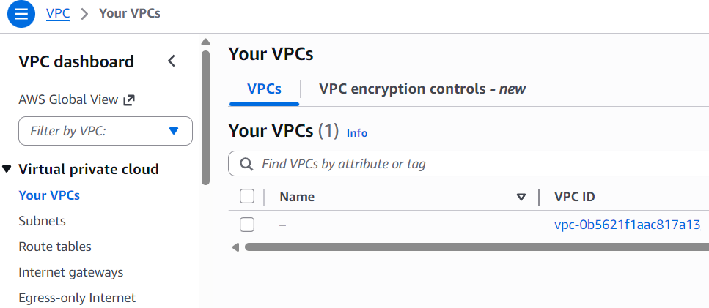
In the VPC dashboard, I selected Your VPCs, which shows a list of VPCs in my account. There was already one default VPC, created by AWS for quick resource launching. Then, I clicked Create VPC to start making my own.
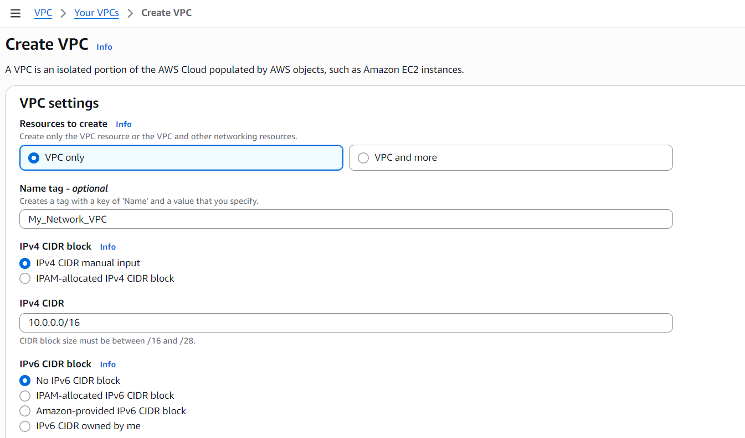
When the Create VPC page opened, I selected VPC only and named it MY_Network_VPC. I set the IPv4 CIDR block to 10.0.0.0/16, giving me a large range of IP addresses for my network. I left all other settings at default and clicked Create VPC.
I chose /16 because it provides up to 65,536 IP addresses, enough to divide into multiple subnets for future resources.

Subnets
Subnets are smaller sections inside a VPC that organize resources and manage traffic. In my account, some subnets already existed because the default VPC includes one subnet for each Availability Zone in the Region.
To continue, I created my own subnet within MY_Network_VPC to plan where my resources will live and operate.
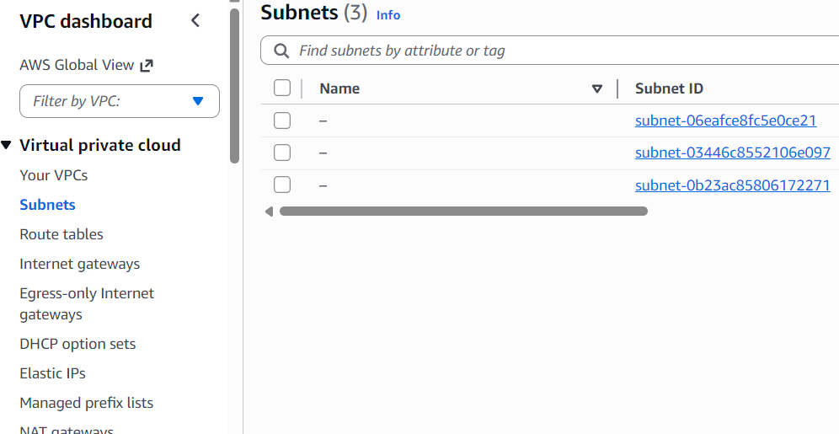
On the VPC dashboard, I selected Subnets from the left panel. By default, there were already three subnets because the default VPC creates one subnet for each Availability Zone in the Region. Then, I clicked Create Subnet on the right to add my own.
Here is what I did to create a subnet:
- On the Create Subnet panel, the first step was to select in which VPC my subnet should be created. I chose MY_Network_VPC because that is the VPC I just created.
- Next, I gave a name to my subnet: My_Subnet1, so I could easily identify it later.
- For Availability Zone, I learned that Availability Zones (AZs) are separate data centers in a region that provide high availability and fault tolerance for resources. There were other options to choose a specific AZ, but I selected No Preference, which means AWS will automatically place my subnet in any AZ in the region.
- The IPv4 VPC CIDR block was already populated as 10.0.0.0/16, which is the IP range of my VPC. I used /16 because it allows up to 65,536 IP addresses to divide across multiple subnets.
- I had to fill the IPv4 Subnet CIDR block, and I chose 10.0.0.0/24, which creates 256 IP addresses for this subnet. I chose /24 because it provides enough addresses for the resources I plan to place here without wasting IPs.
- Finally, I left all other settings at default and clicked Create Subnet to complete the setup.

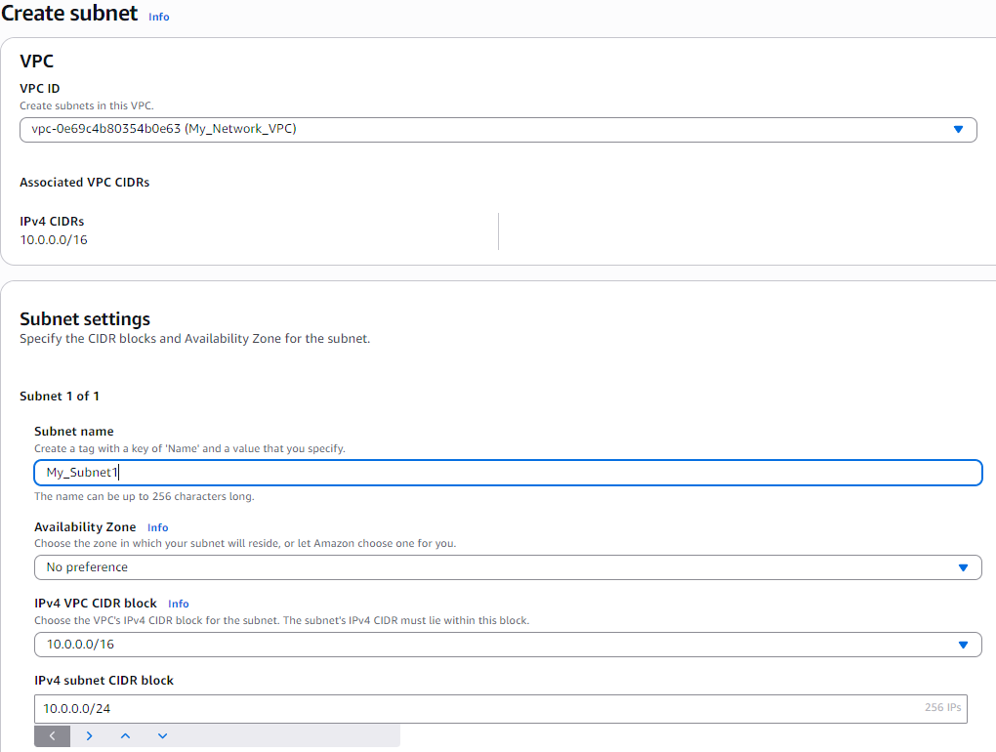
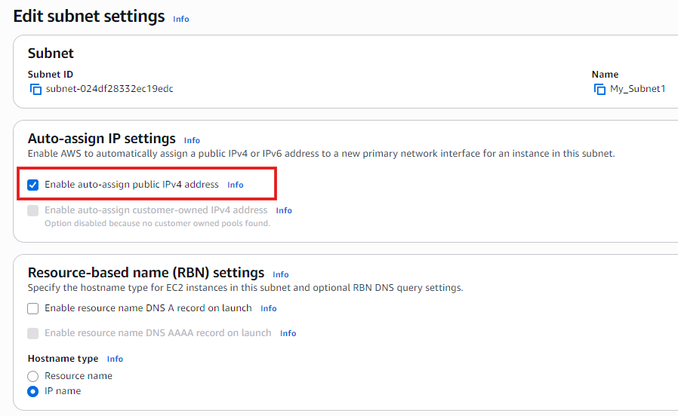
- After creating the subnet, I needed to edit it.
- I selected the subnet I had just created, My_Subnet1, from the list.
- On the right side, I clicked Actions, which opened a drop-down menu.
- From the drop-down, I selected Edit Subnet to modify its settings.
- In the Edit Subnet window, I selected the option Enable auto-assign public IPv4 address under Auto-assign IP settings.
- I did this because enabling it automatically gives any EC2 instance launched in this subnet a public IP, allowing it to access the internet without manual configuration.
- After selecting this option, I clicked Save to apply the changes.

Internet Gateway
Internet gateways are AWS components that let resources in a VPC communicate with the internet. They act like a bridge connecting my private network to the outside world, enabling both outbound and inbound traffic.
In this step, I will create and attach an internet gateway to MY_Network_VPC so my resources can access the internet.
- On the VPC dashboard, I selected Internet Gateways from the left panel.
- I noticed there was already a default internet gateway created by AWS for the default VPC.
- Even so, I decided to create my own internet gateway for MY_Network_VPC to connect my custom network to the internet.
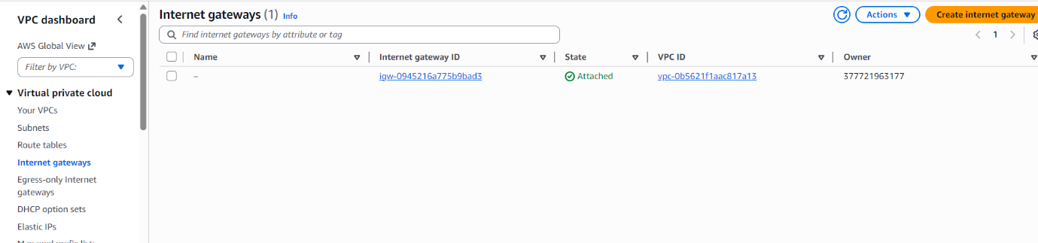
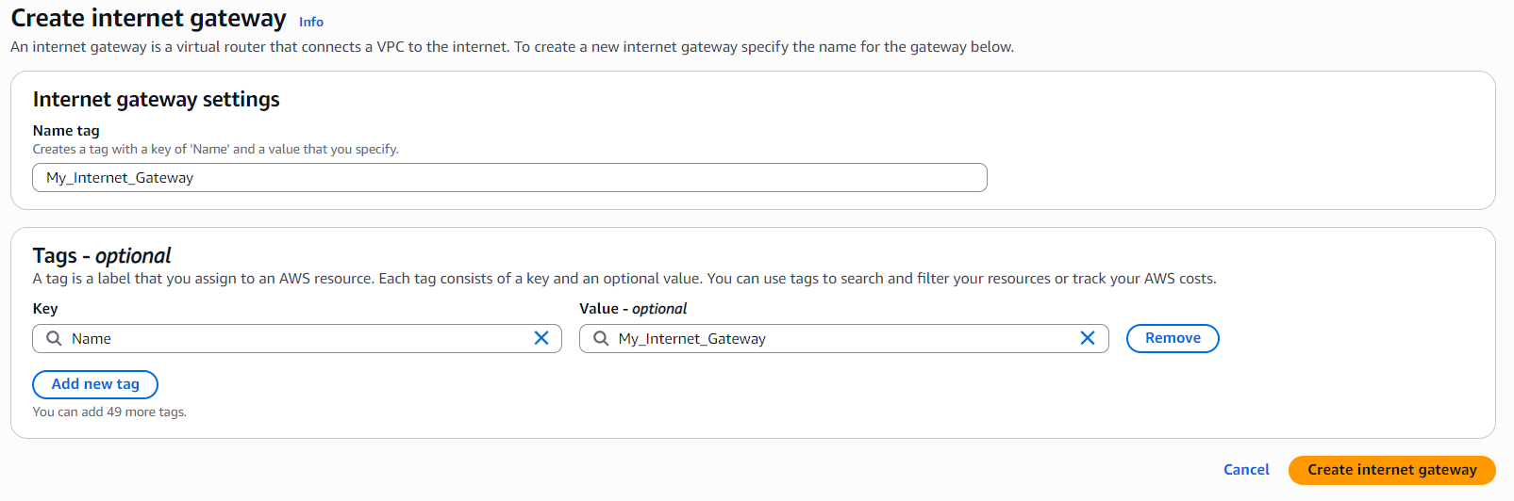
- In the Create Internet Gateway page, I saw that only a name was required.
- I entered MY_Internet_Gateway as the name to identify it easily later.
- After naming it, I clicked Create Internet Gateway to complete the creation.
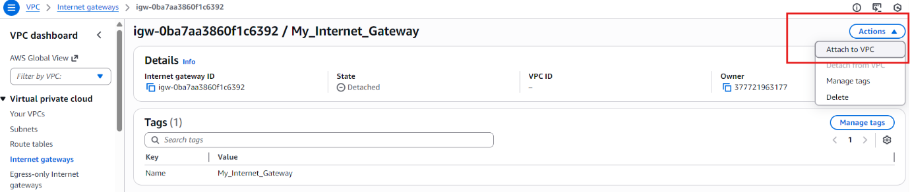
- After creating MY_Internet_Gateway, I noticed it was not yet attached to my VPC.
- On the upper right corner, I clicked Actions and selected Attach to VPC.
- In the next window, I selected MY_Network_VPC and clicked Save to attach the internet gateway to my VPC.
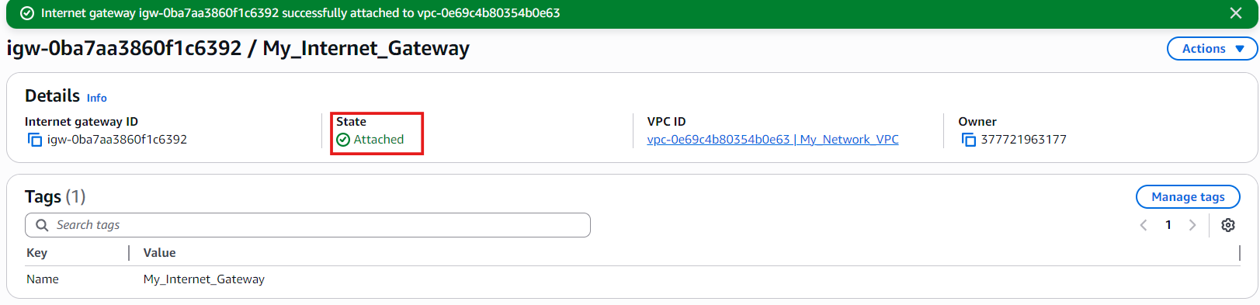
- After clicking Save, I went back to the dashboard and saw that MY_Internet_Gateway now showed “Attached” in the state field.
- This confirmed that my internet gateway was successfully connected to MY_Network_VPC, allowing resources in my VPC to communicate with the internet.

Conclusion
In this project, I created my own VPC, added a subnet, and attached an internet gateway in AWS. Through this process, I learned how to design a private network, organize resources, and enable secure internet access for cloud instances.
This project was important because it helped me understand the foundations of AWS networking, including IP addressing, subnets, and internet connectivity. These skills are essential for building scalable and secure cloud environments, which will be useful for more advanced cloud architectures in the future.

